# **Name: Abdurrahman Qureshi**

# **Roll No: 210451**

Practical No: 3

**1) WAP to read, write and display an array using literals**

**CODE:**

<html>

<head>

<title>EXP 3 - A</title>

<script>

let myArray = [1, 2, 3, 4, 5];

document.write("<h3>Array Elements:</h3>")

for (const item of myArray) {

document.write("<h3>" + item + "</h3>");

}

</script>

<style>

h3 {

color: #ccc;

}

</style>

</head>

<body style="background-color: #111">

<footer>

<h3>Abdurrahman Qureshi</h3>

<h3>210451</h3>

</footer>

</body>

</html>

**OUTPUT:**

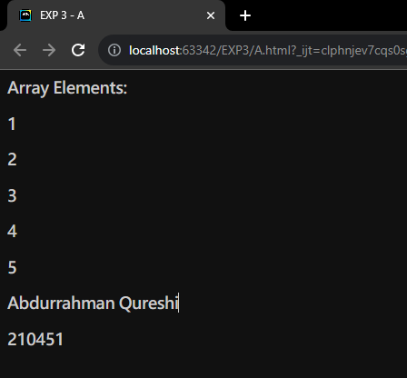

**2) WAP to sort an array**

**CODE:**

<html>

<head>

<title>EXP 3 - B</title>

<script>

let myArray = [12, 25, 10, 9, 5, 7, 2, 45, 20];

document.write("<h3>Array Elements:</h3>");

for (const item of myArray) {

document.write(item + " ");

}

for (let i = 0; i < myArray.length; i++) {

for (let j = i + 1; j < myArray.length; j++) {

if (myArray[j] < myArray[i]) {

let temp = myArray[i];

myArray[i] = myArray[j];

myArray[j] = temp;

}

}

}

document.write("<h3>Sorted Array Elements:</h3>");

for (const item of myArray) {

document.write(item + " ");

}

</script>

<style>

* {

color: #ccc;

}

</style>

</head>

<body style="background-color: #111">

<footer>

<h3>Abdurrahman Qureshi</h3>

<h3>210451</h3>

</footer>

</body>

</html>

**OUTPUT:**

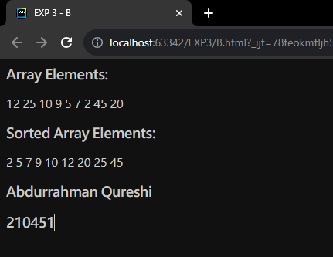

**3) WAP to display length of the array**

**CODE:**

<html>

<head>

<title>EXP 3 - C</title>

<script>

let myArray = [12, 25, 10, 9, 5, 7, 2, 45, 20];

document.write("<h3>Array Elements:</h3>");

for (const item of myArray) {

document.write(item + " ");

}

let x = myArray.length;

document.write("<h3> Array Length: " + x + "</h3>");

</script>

<style>

* {

color: #ccc;

}

</style>

</head>

<body style="background-color: #111">

<footer>

<h3>Abdurrahman Qureshi</h3>

<h3>210451</h3>

</footer>

</body>

</html>

**OUTPUT:**

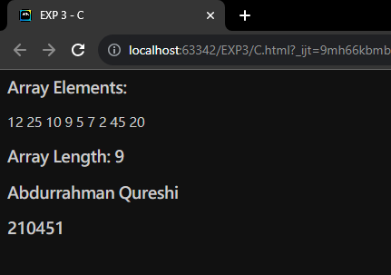

**4) WAP to display a sparse array**

**CODE:**

<html>

<head>

<title>EXP 3 - D</title>

<script>

let myArray = [];

document.write("<h3>Array Elements:</h3>");

myArray[0] = "Spectre";

myArray[2] = "Firebreak";

myArray[4] = "Outrider";

myArray[6] = "Blackjack";

for (const item of myArray) {

document.write(item + " ");

}

</script>

<style>

* {

color: #ccc;

}

</style>

</head>

<body style="background-color: #111">

<footer>

<h3>Abdurrahman Qureshi</h3>

<h3>210451</h3>

</footer>

</body>

</html>

**OUTPUT:**

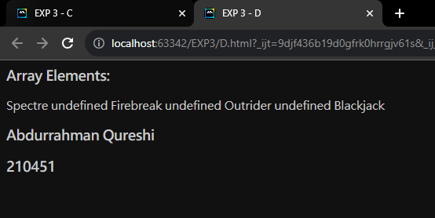

**5) WAP to demonstrate the use of splice method**

**CODE:**

<html>

<head>

<title>EXP 3 - E</title>

<script>

let myArray = [];

myArray[0] = "Spectre";

myArray[1] = "Firebreak";

myArray[2] = "Outrider";

myArray[3] = "Blackjack";

document.write("<h3>Array Elements:</h3>");

for (const item of myArray) {

document.write(item + " ");

}

myArray.splice(2, 0, "Reaper", "Nomad");

document.write("<h3>Array Elements after only adding:</h3>");

for (const item of myArray) {

document.write(item + " ");

}

myArray.splice(1, 1, "Battery", "Ruin");

document.write("<h3>Array Elements after deleting the first index:</h3>");

for (const item of myArray) {

document.write(item + " ");

}

</script>

<style>

* {

color: #ccc;

}

</style>

</head>

<body style="background-color: #111">

<footer>

<h3>Abdurrahman Qureshi</h3>

<h3>210451</h3>

</footer>

</body>

</html>

**OUTPUT:**

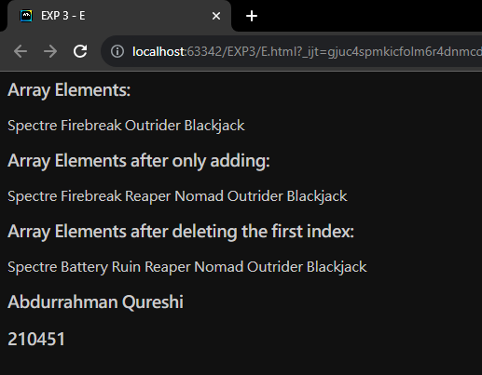

**6) WAP to add element to array using a different method**

**CODE:**

<html>

<head>

<title>EXP 3 - F</title>

<script>

let myArray = [];

myArray[0] = "Spectre";

myArray[1] = "Firebreak";

myArray[2] = "Outrider";

myArray[3] = "Blackjack";

document.write("<h3>Array Elements:</h3>");

for (const item of myArray) {

document.write(item + " ");

}

let newValues = "Ajax";

let newArray = myArray.concat(newValues);

document.write("<h3>Array Elements after adding an element:</h3>");

for (const item of newArray) {

document.write(item + " ");

}

</script>

<style>

* {

color: #ccc;

}

</style>

</head>

<body style="background-color: #111">

<footer>

<h3>Abdurrahman Qureshi</h3>

<h3>210451</h3>

</footer>

</body>

</html>

**OUTPUT:**

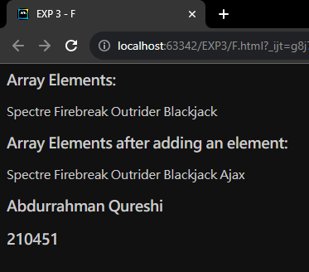

**7) WAP to delete element to array using a different method**

**CODE:**

<html>

<head>

<title>EXP 3 - G</title>

<script>

let myArray = [];

myArray[0] = "Spectre";

myArray[1] = "Firebreak";

myArray[2] = "Outrider";

myArray[3] = "Blackjack";

document.write("<h3>Array Elements:</h3>");

for (const item of myArray) {

document.write(item + " ");

}

let delValues = "Outrider";

let newArray = myArray.filter(e => e !== delValues);

document.write("<h3>Array Elements after adding an element:</h3>");

for (const item of newArray) {

document.write(item + " ");

}

</script>

<style>

* {

color: #ccc;

}

</style>

</head>

<body style="background-color: #111">

<footer>

<h3>Abdurrahman Qureshi</h3>

<h3>210451</h3>

</footer>

</body>

</html>

**OUTPUT:**

